**MongoDB Lab Assignments -Day 1**

**MongoDB Exercise in mongo shell**

Connect to a running mongo instance, use a database named **mongo_practice**.

Document all your queries in a javascript file to use as a reference.

**Insert Documents**

Insert the following documents into a **movies** collection.

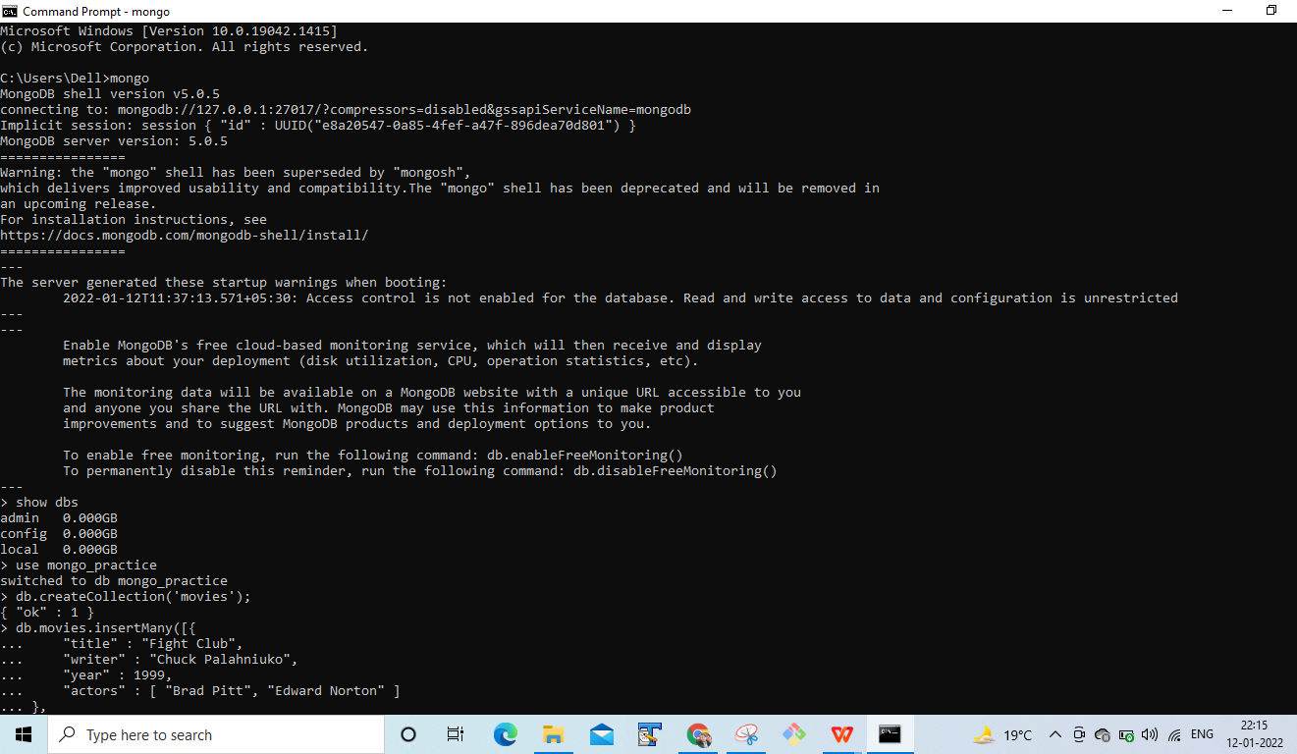

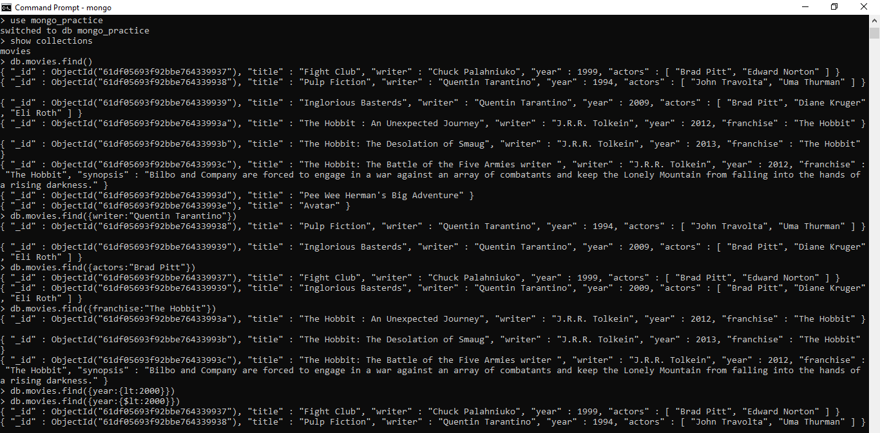

**Query / Find Documents**

query the **movies** collection to

**get all documents**



**get all documents with writer set to "Quentin Tarantino"**



**get all documents where actors include "Brad Pitt"**



**get all documents with franchise set to "The Hobbit"**



**get all movies released in the 90s**



**get all movies released before the year 2000 or after 2010**

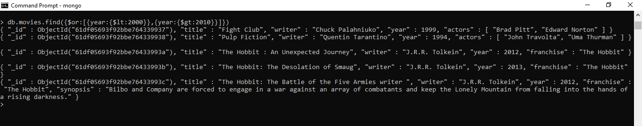

**Update Documents**

1. add a synopsis to "The Hobbit: An Unexpected Journey" : "A reluctant hobbit, Bilbo Baggins, sets out to the Lonely Mountain with a spirited group of dwarves to reclaim their mountain home - and the gold within it - from the dragon Smaug."

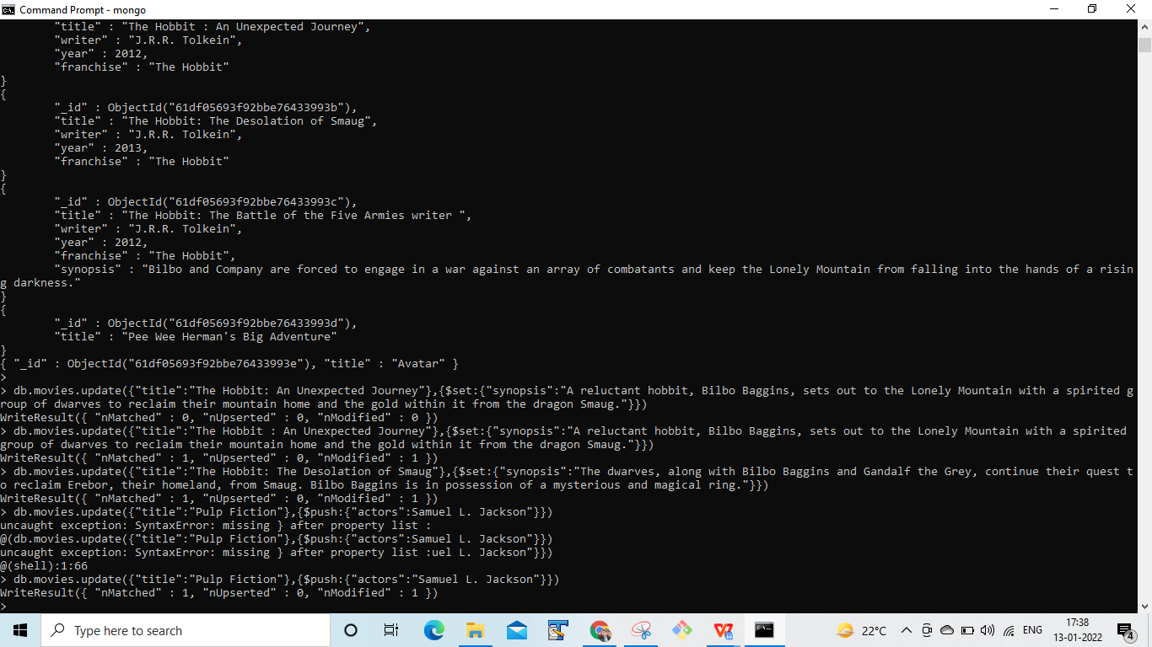

2. add a synopsis to "The Hobbit: The Desolation of Smaug" : "The dwarves, along with Bilbo Baggins and Gandalf the Grey, continue their quest to reclaim Erebor, their homeland, from Smaug. Bilbo Baggins is in possession of a mysterious and magical ring."



3. add an actor named "Samuel L. Jackson" to the movie "Pulp Fiction"



**Text Search**

1. find all movies that have a synopsis that contains the word "Bilbo"

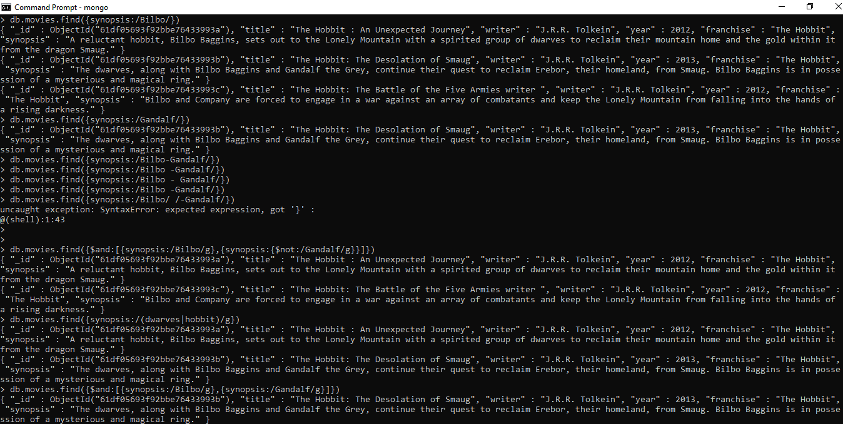

2. find all movies that have a synopsis that contains the word "Gandalf"



3. find all movies that have a synopsis that contains the word "Bilbo" and not the word "Gandalf"



4. find all movies that have a synopsis that contains the word "dwarves" or "hobbit"



5. find all movies that have a synopsis that contains the word "gold" and "dragon"

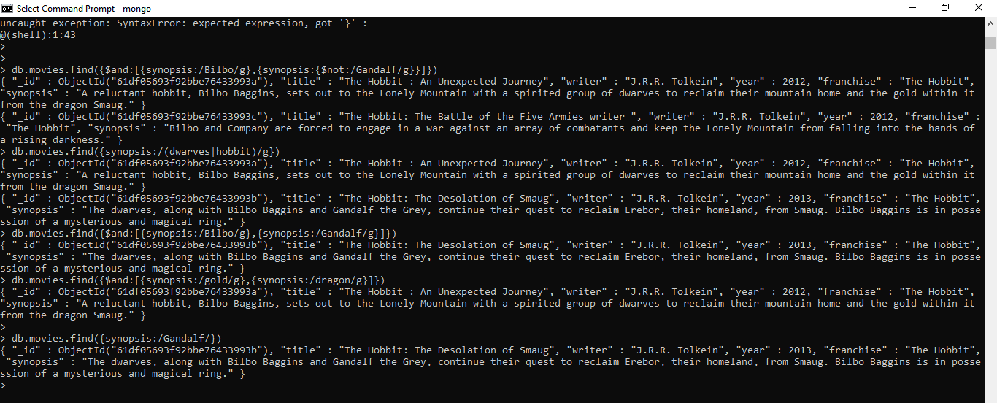

**Relationships**

Insert the following documents into a **users** collection

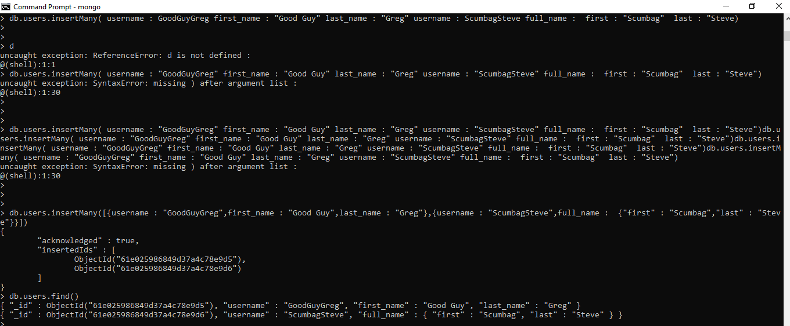

Insert the following documents into a **posts** collection

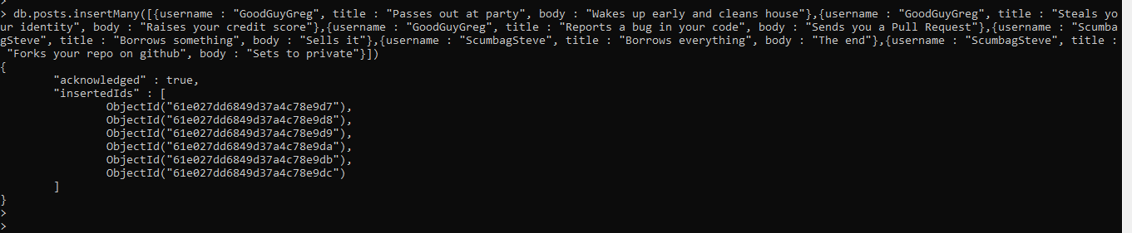

Insert the following documents into a comments collection

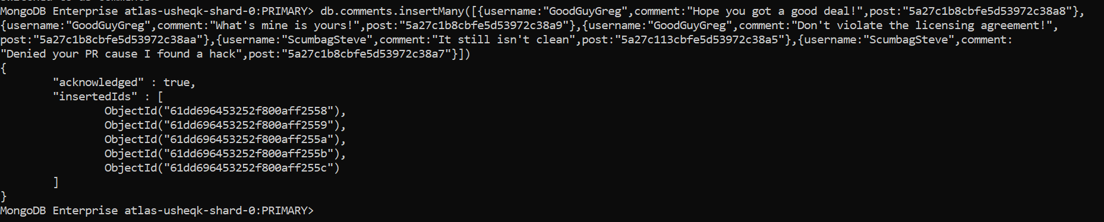

**Querying related collections**

1. find all users

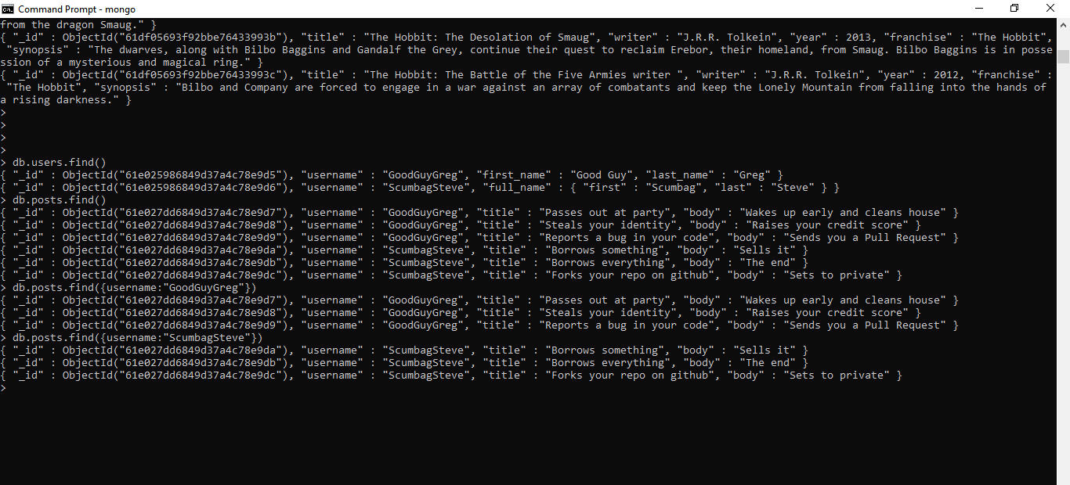

1. find all posts



3. find all posts that was authored by "GoodGuyGreg"



4. find all posts that was authored by "ScumbagSteve"

